|  |  |  |  |
| --- | --- | --- | --- |
| **Date:** | **04-06-2020** | **Name:** | **Rohan shetty** |
| **Course:** | **Digital Design Using HDL** | **USN:** | **4AL17EC079** |
| **Topic:** | **Hardware Modeling using**  **Verilog**  **Implement T Flip-Flop** | **Semester**  **& Section:** | **6th & ‘B’** |
| **Github**  **Repository:** | **rohan-shetty-online-courses** |  |  |

|  |
| --- |
| **FORENOON SESSION DETAILS** |
| **Image of session** |
| **Report –Hardware Modeling Using Verilog Objective of Hardware Modeling Using Verilog**   * Learn about the Verilog hardware description language. * Understand the difference between behavioral and structural design styles. * Learn to write test benches and analyze simulation results. * Learn to model combinational and sequential circuits, * Distinguish between good and bad coding practices. * Case studies with some complex designs.   **VLSI Design Process**   * **Design complexity increasing rapidly**   + Increased size and complexity   + Fabrication technology improving   + CAD tools are essential   + Conflicting requirements like area, speed, and energy consumption |

|  |
| --- |
| * **The present trend**   + Standardize the design flow   + Emphasis on low-power design, and increased performance **Moore’s Law** * Exponential growth * Design complexity increases rapidly * Automated tools are essential * Must follow well defined design flow   **Standardized design procedure**   * Starting from the design idea down to the actual implementation.   **Encompasses many steps:**   * Specification Synthesis * Simulation * Layout Testability analysis * and many more   **Need to use Computer Aided Design (CAD) tools.**   * Hardware Description Language (HDL) * Based on HDL provide formats for representing the outputs of various design steps * A CAD tool transforms its HDL input into a HDL output that contains more detailed information about the hardware.   + Behavioral level to register transfer level   + Register transfer level to gate level   + Gate level to transistor level   + Transistor to the layout level **Two Competing HDL’s** * Verilog * VHDL   **Behavioral design**   * Specify the functionality of the design in terms of its behavior. * Various ways of specifying:   + Boolean expression or truth table.   + Finite-state machine behavior (e.g. state transition diagram or table).   + In the form of a high-level algorithm. * Needs to be synthesized into more detailed specifications for hardware realization, **Data path design** * Generate a netlist of register transfer level components, like registers, adders, multipliers,   multiplexers, decoders, etc.   * A netlist is a directed graph, where the vertices indicate components, and the edges   indicate interconnections. |



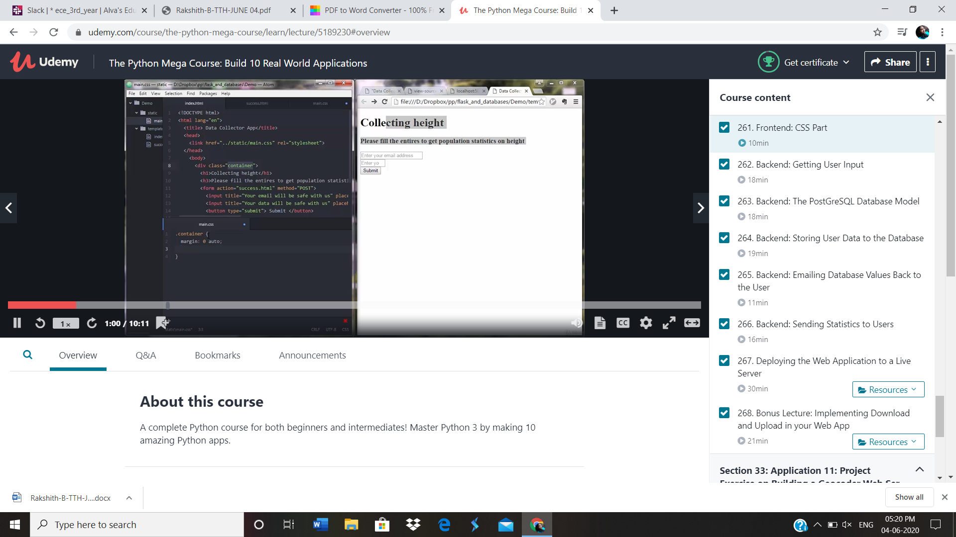

app.py

from flask import Flask, render_template, request from flask.ext.sqlalchemy import SQLAlchemy

from send_email import send_email from sqlalchemy.sql import func

app=Flask( name ) app.config['SQLALCHEMY_DATABASE_URI']='postgresql://postgres:postgr es123@localhost/height_collector'

db=SQLAlchemy(app)

class Data(db.Model):

tablename ="data" id=db.Column(db.Integer, primary_key=True)

email_=db.Column(db.String(120), unique=True) height_=db.Column(db.Integer)

def init (self, email_, height_): self.email_=email_ self.height_=height_

@app.route("/") def index():

return render_template("index.html")

@app.route("/success", methods=['POST']) def success():

if request.method=='POST': email=request.form["email_name"] height=request.form["height_name"] print(email, height)

if db.session.query(Data).filter(Data.email_ == email).count()== 0:

data=Data(email,height) db.session.add(data) db.session.commit()

average_height=db.session.query(func.avg(Data.height_)).scalar() average_height=round(average_height, 1)

count = db.session.query(Data.height_).count() send_email(email, height, average_height, count) print(average_height)

return render_template("success.html")

return render_template('index.html', text="Seems like we got something from that email once!")